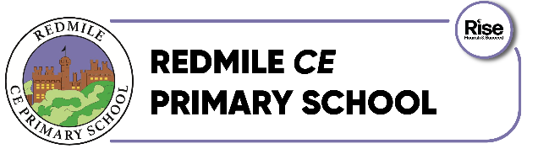
Collective Worship Overview
2026-2027 - Autumn Term 1
w/c | Value | Reflection Music | Hymn | Monday | Tuesday | Wednesday | Thursday | Friday
24th August | Vision and Values  Behaviour | Cannon and Ball Together we’ll be ok |  | Vision and Values  Behaviour | Picture News | Pupil Leadership | The Big Umbrella by Amy June Bates  https://www.youtube.com/watch?v=d7JZ9rRIZ3w | House Points
31st August | Vision/Values | Mozart  Piano Concert 21 - Andante | Colours of Day | - | Picture News | Pupil Leadership | Reverend Monica | Lights Across the World
7th Sept | Generosity | Beethoven  Moonlight Sonata | Magic Penny | Generosity | Picture News | Pupil Leadership | Here is a book by Elesha Cooper  https://www.youtube.com/watch?v=R_KZDzSxPp8 | Lights Across the World
14th Sept | Compassion | Beethoven  Fur Elise | Cross Over the Road, My Friend | Compassion | Picture News | Pupil Leadership | Splash by Claire Cashmore  https://www.youtube.com/watch?v=ZvXvc64Y-Io | Celebration
21st Sept | Thankfulness  Harvest | Mozart  Eine Kleine Nachtmusik | Thank You Lord | Thankfulness | Picture News | Pupil Leadership | The Tale of a Toothbrush by M G Leonard  https://www.youtube.com/watch?v=HgHYDul9ecg | Lights Across the World
28th Sept | Respect  Harvest | Rossini  Voces para la Paz | Harvest Songs | Respect  Harvest | Picture News | Pupil Leadership | This is not a small voice by Traci N Todd  https://www.youtube.com/watch?v=WEhq2i4XLes | Lights Across the World
5th  Oct | Harvest | Haydn  Symphony 31 | Harvest Songs | Harvest | Picture News | Pupil Leadership | HARVEST  FESTIVAL | Lights Across the World
12th  Oct | British Values | The Carnival of Venica | Kum Ba Yah | British Values | Picture News | Pupil Leadership | Celebration | -

