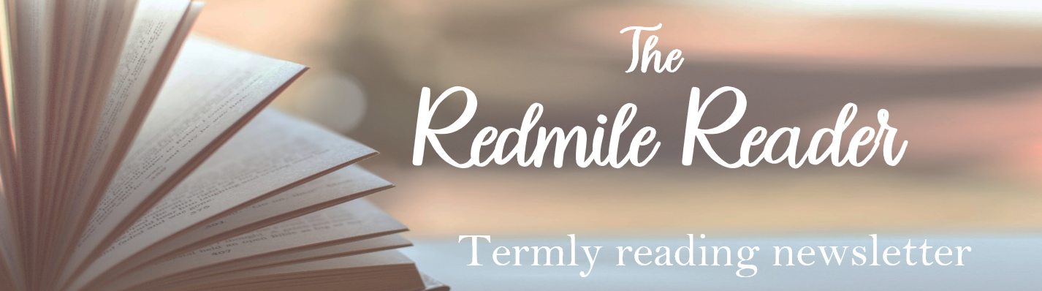
Library Openings |  |  |  |  |  |  |  |  |  |  | 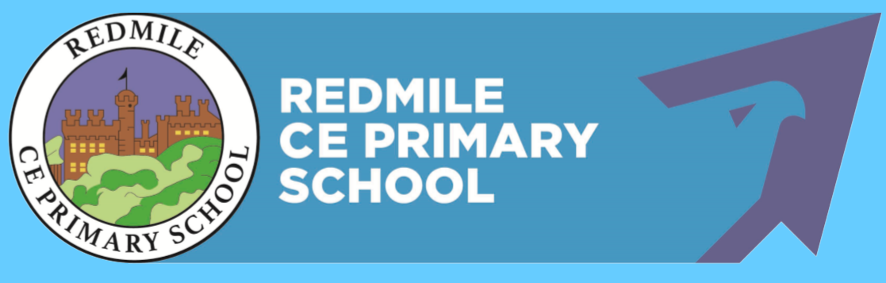  Autumn  2024-2025
Mobile Library – Mobile A, Route 6 - Tuesdays
17th Sept; 8th Oct; 29th Oct; 19th Nov; 10th Dec
Village |  |  | Stopping Place |  |  |  |  | Times
Redmile |  |  | Main Street |  |  |  |  | 10:45 – 11:05
Barkestone |  |  | New Causeway/Bus Stop |  |  |  |  | 11:15 – 11:35
 | Bottesford |  |  |  |  |  | Grantham |  |  |  |  | Bingham
Mon | - |  |  |  |  |  | 9:00am – 5:00pm |  |  |  |  | 9:30am – 5:00pm
Tues | 3:00pm – 6:00pm |  |  |  |  |  | 9:00am – 5:00pm |  |  |  |  | 9:30am – 5:00pm
Wed | - |  |  |  |  |  | 9:00am – 5:00pm |  |  |  |  | 9:30am – 5:00pm
Thurs | 9:30am – 12:30pm |  |  |  |  |  | 9:00am – 6:00pm |  |  |  |  | 9:30am – 5:00pm
Fri | 3:00pm –6:00pm |  |  |  |  |  | 9:00am – 5:00pm |  |  |  |  | 9:30am – 5:00pm
Sat | 9:30pm – 12:30pm |  |  |  |  |  | 9:00am – 4:00pm |  |  |  |  | 9:30am – 4:00pm
Sun | - |  |  |  |  |  | Closed |  |  |  |  | Closed


If you are a member of the Nottinghamshire Inspire Libraries (Bingham), you will be able to access a range of ebooks and audio books through the Borrow Box app or website. Sign-in using your library card number and PIN. Contact Bingham Library for your free membership details.
Reading at Redmile
These are just some of the books we will be reading in class this term:
EYFS |  |  |  |  | Class 1 |  |  |  | Class 2 |  |  |  | Class 3
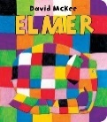  Elmer |  | 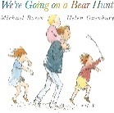  We’re Going on a Bear Hunt |  |  | 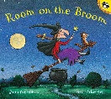  Room on the Broom | 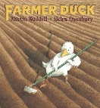  Farmer Duck |  |  | 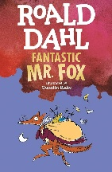  Leonora Bolt: Secret Inventor  by Roald Dahl | 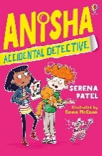  Anisha: Accidental Detective  by Serena Patel |  |  | 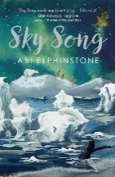  Sky Song  by Abi Elphinstone | 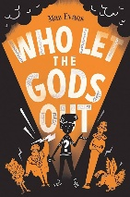  Who Let the Gods Out  by Maz Evans
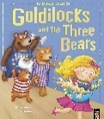  Goldilocks |  | 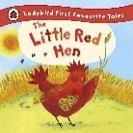  Little Red Hen |  |  | 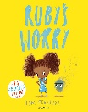  Ruby’s Worry | 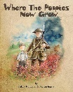  Where the Poppies Now Grow
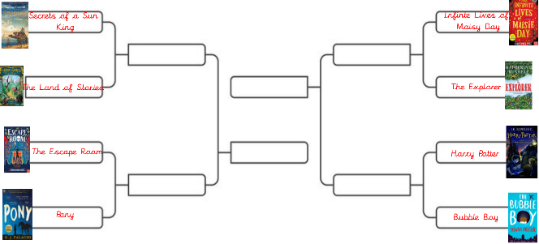
The Reading World Cup!

As well as our class novel studies which form our Reading Curriculum, all classes have reading for pleasure books as well. These are read by the teacher every day during story-time.

In KS2, these books are voted for by the class, with recommendations from the children and teachers together.

Book Suggestions
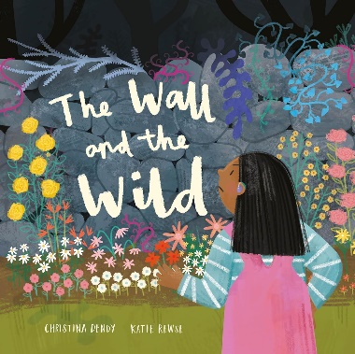 |  |  |  |   The Wall and the Wild by Christina Dendy  Recommended for Reception, Year 1 and Year 2  This book first grabbed me with its language and vocabulary – ‘constellations of leaves’… what an image! But this book is also a fantastic learning and discussion point for climate change and biodiversity!  Ana grows only perfectly-sizes plants and flowers, and throws everything else over the wall into the Wild. But as her garden gets neater, the Wild begins to grow…
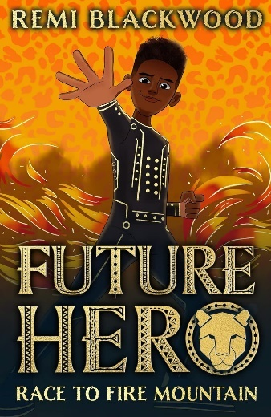 |  |  |  |   Race to Fire Mountain by Remi Blackwood  Recommended for Years 3 and 4  Another language-rich book for Years 3 and 4, but told in accessible short chapters! This is the first of the 4-book Future Hero series and has completely swept up a storm!  When Jarell discovers that the fantasy world he is obsessed with doodling is actually real, he is launched into an incredible adventure.  Ulfrika, the land of his ancestors, is in trouble and he is the hero they need. With the help of brave and wise-cracking Kimisi, Jarell must stop the evil Ikala. The future of Ulfrika depends on it...
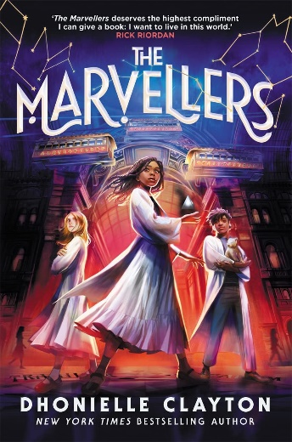 |  |  |  |   The Marvellers by Dhonielle Clayton  Recommended for Years 5 and 6  First of all – this is nothing to do with Marvel…  This is a book that is so easy to fall in love with – the word and the characters are so rich and vivid that is absolutely deserves the celebration it has received since last year.  Ella attends a magic school for Marvellers from around the world. She finds friendship in fellow misfits Brigit, a girl who hates magic, and Jason, a boy with a fondness for magical creatures and support from her Elixirs teacher, Masterji Thakur.  When the notorious Ace of Anarchy escapes prison and Masterji Thakur mysteriously disappears, Ella finds herself as the prime suspect…
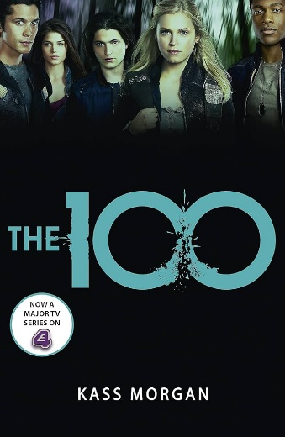 |  |  |  |   The 100 by Kass Morgan  Recommended for grown-ups  This is a series that can absolutely capture you… It’s described as ‘The Hunger Games meets Lost’, and that is spot on!  After a devastating nuclear war, humans have lived on spaceships far above the Earth’s radioactive surface. Now, 100 juvenile delinquents are being sent on a dangerous mission to recolonise the planet. Among them are Clarke, Wells (the Chancellor’s son) and reckless Bellamy – never meant to be heroes, but they could be mankind’s last hope. Confronted with a savage land and haunted by secrets from their pasts, the hundred must fight to survive.
Check out the Reading for Pleasure page on our school website for more reading inspiration and recommendations.


