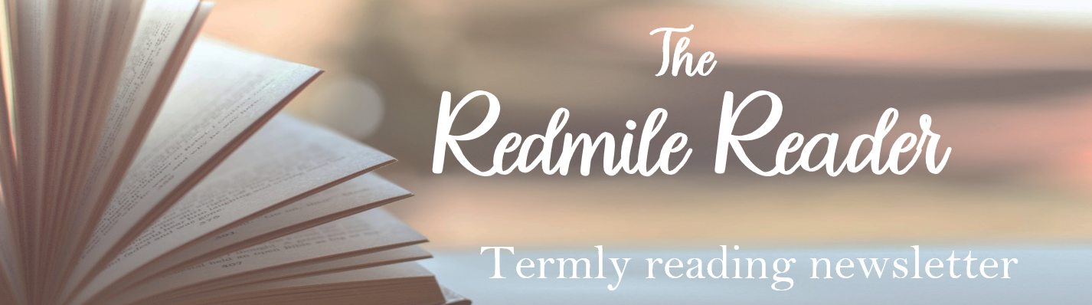
Library Openings |  |  |  |  |  |  |  |  |  |  |  |  |  |   Summer  2024-2025
Mobile Library – Mobile A, Route 6 - Tuesdays
15th April |  |  | 6th May |  |  |  | 27th May |  |  |  |  | 17th June
The Mobile Library Service now visits on a three-weekly basis.
Village |  |  |  | Stopping Place |  |  |  |  |  | Times
Redmile |  |  |  | Main Street |  |  |  |  |  | 10:45 – 11:05
Barkestone |  |  |  | New Causeway/Bus Stop |  |  |  |  |  | 11:15 – 11:35
 | Bottesford |  |  |  |  |  |  |  | Grantham |  |  |  |  |  | Bingham
Mon | - |  |  |  |  |  |  |  | 9:00am – 5:00pm |  |  |  |  |  | 9:30am – 5:00pm
Tues | 3:00pm – 5:00pm |  |  |  |  |  |  |  | 9:00am – 5:00pm |  |  |  |  |  | 9:30am – 5:00pm
Wed | - |  |  |  |  |  |  |  | 9:00am – 5:00pm |  |  |  |  |  | 9:30am – 5:00pm
Thurs | 9:30am – 12:30pm |  |  |  |  |  |  |  | 9:00am – 6:00pm |  |  |  |  |  | 9:30am – 5:00pm
Fri | 3:00pm –5:00pm |  |  |  |  |  |  |  | 9:00am – 5:00pm |  |  |  |  |  | 9:30am – 5:00pm
Sat | 9:30pm – 12:30pm |  |  |  |  |  |  |  | 9:00am – 4:00pm |  |  |  |  |  | 9:30am – 4:00pm
Sun | - |  |  |  |  |  |  |  | Closed |  |  |  |  |  | Closed


If you are a member of the Nottinghamshire Inspire Libraries (Bingham), you will be able to access a range of ebooks and audio books through the Borrow Box app or website. Sign-in using your library card number and PIN. Contact Bingham Library for your free membership details.
Reading at Redmile
These are just some of the books we will be reading in class this term:
EYFS |  |  |  |  |  | Class 1 |  |  |  |  | Class 2 |  |  |  |  | Class 3
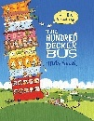  The 100 Decker Bus |  | 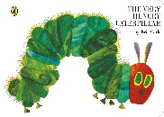  The Very Hungry Caterpillar |  |  |  | 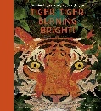  Tiger, Tiger, Burning Bright |  | 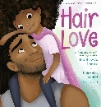  Hair Love |  |  | 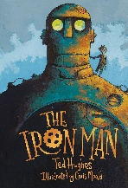  The Iron Man  by Ted Hughes |  | 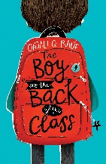  The Boy at the Back of the Class  by Onjali Q Rauf |  |  | 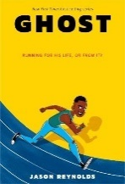  Ghost  by Jason Reynolds | 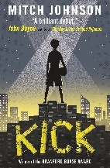  Kick  by Mitch Johnson
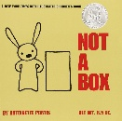  Not a Box |  | 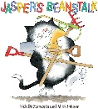  Jasper’s Beanstalk |  |  |  | 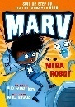  Marv and the Robot |  | 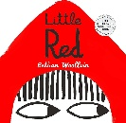  Little Red
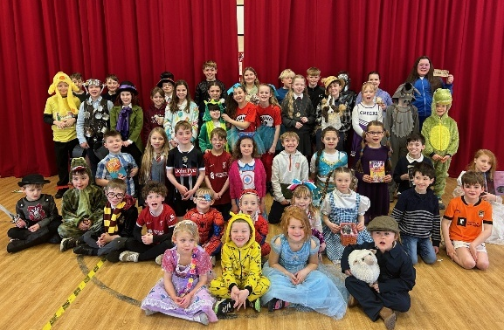
World Book Day
A day full of imagination, creativity, and a love for reading. The children had an absolute blast turning simple potatoes into their favourite book
characters! With a bit of paint, fabric, and a lot of imagination, they created everything from fairy-tale princesses to adventurous heroes. The creativity was on full display as each child put their personal touch on their potato creation, bringing their characters to life. It was a joy to see the proud smiles as they shared their creations with classmates.
We would like to thank all the parents for your support and encouragement in making this event such a success. Your help with the potato creations and your enthusiasm for reading with your child has truly contributed to the fun and excitement of the day.
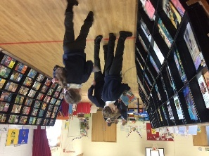
The Rovin’ Bookshop

The children were able to show off their love of reading when choosing their next selection of books to read! It was great to hear such discussion over books as the children were recommending their favourites to each other. Thank you so much for your support
Book Suggestions
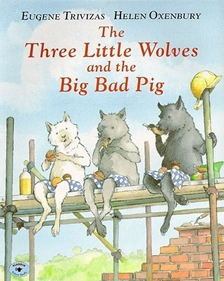 |  |  |  |  | The Three Little Wolves and the Big Bad Pig by Eugene Trivizas  Recommended for Reception, Year 1 and Year 2  We love a twist on a traditional tale, and this twist on ‘The Three Little Pigs’ is one of my all-time favourites. In this hilarious new version of the story, the three little wolves build houses of bricks, concrete and steel in an attempt to escape the Big Bad Pig, who is well armed with a tool kit including a sledgehammer and a pneumatic drill.  This is one of my daily bedtime reads with Bella at home, so I hope you find just as much enjoyment as we do!
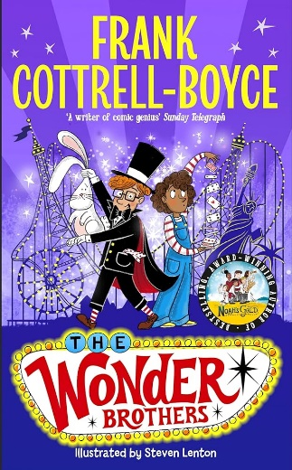 |  |  |  |  | The Wonder Brothers by Frank Cottrell-Boyce  Recommended for Years 3 and 4  An author that I’d generally recommend for our older readers, but it would be unfair to hide this book from Class 2!  Cousins Middy and Nathan are obsessed with magic. Not the kind with wands and spells, but real stage magic, with capes, tricks, and disappearing acts. When Blackpool Tower vanishes during the Big Switch-On, Nathan promises (on live TV!) that they’ll bring it back—with magic!  With just a sparkly cape and a stick of rock, they suddenly find themselves in Las Vegas, where the world’s greatest magician, Perplexion, performs. But Vegas is full of secrets, and in a city where nothing is what it seems, Middy and Nathan are in for their biggest trick yet...
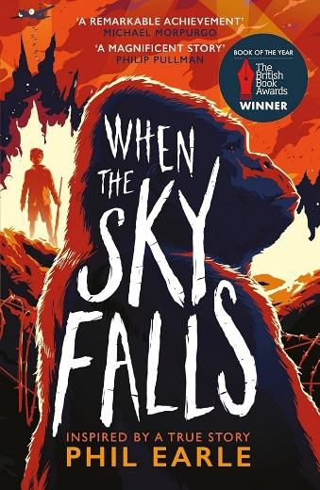 |  |  |  |  | When the Sky Falls by Phil Earle  Recommended for Years 5 and 6  This was a recent find of mine, and I know the Year 5s and 6s have been captivated by stories set in the wars.  It follows Joseph, a boy living in the city during the Blitz, where he’s placed with the stern Mrs. F, who owns a rundown zoo. There, he forms a deep and unexpected bond with Adonis, a silverback gorilla whose strength is matched only by his gentleness. The relationship between boy and beast is powerful, tender, and filled with tension—especially as the threat of bombs grows closer. Based on a true story, it’s a beautifully written tale about trust, resilience, and the unlikely friendships that carry us through the darkest times.
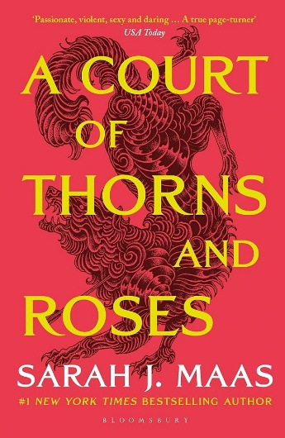 |  |  |  |  | A Court of Thorns and Roses by Sarah J Mass  Recommended for grown-ups!  A new genre for me – ‘Romantasy’ - but I am absolutely hooked! Having absolutely devoured the 5-book series over the past month, I’m now working my way through a whole new realm of fantasy authors…  A Court of Thorns and Roses (‘ACOTAR’) tells the story of 19-year-old Feyre, a mortal girl trying to keep herself and her sisters alive. After being captured for killing a faerie disguised as a wolf, she is taken to the faerie realm of Prythian. Her captor, Tamlin – High Lord of the Spring Court, initially seems a beast, but their relationship gradually shifts from hostility as Feyre adapts to her new life. However, a growing dark force threatens Prythian, and Feyre must find a way to stop it by potentially dooming Tamlin and his world.  At a glance, I’d summarise as Beauty and the Beast meets the Hunger Games. However, as the plot unfolds, it becomes so much bigger than that…

